**Planning**

**Requirements**

**Cost Determination**

**Development/Testing**

**Maintenance**

Planning

Task arranging is a control for expressing how to finish an undertaking inside a certain time period, generally with characterized stages, and with assigned assets. One perspective on project arranging isolates the movement into:

* Setting goals (these ought to be quantifiable)
* Recognizing expectations
* Arranging the timetable
* Making supporting arrangements

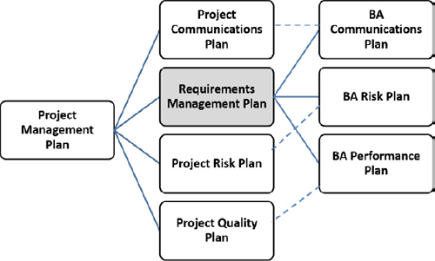

Requirements

* Master Judgment
* Information Gathering
* Information Analysis
* Dynamic
* Information Representation
* Relational and Team Skills
* Setting Diagram
* Models

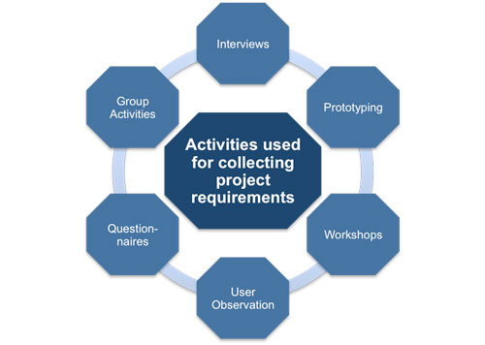

Cost determination:

Cost assessment in project the executives are the way toward anticipating the monetary and different assets expected to finish a task inside a characterized scope. Cost assessment represents every component needed for the venture—from materials to work—and figures an aggregate sum that decides an undertaking's spending plan.

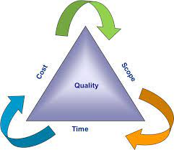

Development/Testing

Advancement testing is a product improvement measure that includes synchronized utilization of a wide range of imperfection avoidance and discovery techniques to diminish programming improvement dangers, time, and expenses.

Test Management is a cycle of dealing with the testing exercises to guarantee superior grade and very good quality testing of the product application. The strategy comprises of getting sorted out, controlling, guaranteeing recognizability and deceivability of the testing interaction to convey the great programming application. It guarantees that the product testing measure runs true to form.

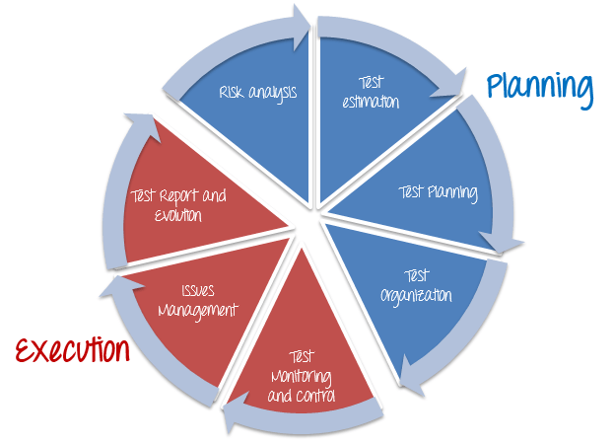

Maintenance

At its heart, project support involves rehearsing some extremely basic qualities over the span of your venture. It implies being purposeful about keeping tabs on your development toward achievements and objectives, rather than accepting all that will occur as arranged. For the support chief, the work plan for the year might be a progression of little individual undertakings or a mix of a couple of huge activities planned around more modest, more adaptable ventures. Whatever the work plan, the accomplishment of the arrangement is reliant upon the support administrator's capacity to deal with the aggregate work plan. Specifically:

* Investigating the turn out needed for each undertaking
* Assessing material and work costs
* Recognizing all help necessities (like hardware, allows and support costs)

